**Task**

**By Rupinder Kaur**

**Step 1:**

In order to download pictures from Google, we used a little bit of Javscript to get the “urls“ of the pictures. The steps used to download pictures is shown in the below scrrenshot.

After following the above steps, it automatically downloaded the “urls.txt“ file which has been included in the task folder for reference.

Followed by this, the next steps for Step 1 have been done in Jupyter notebook and following are the screenshots.

The above snapshot shows the links of 100 urls stored in “urls.txt“ file and the below screenshot will show the images downloading in the folder named “original_images“.

The images in folder reflected in the following way:

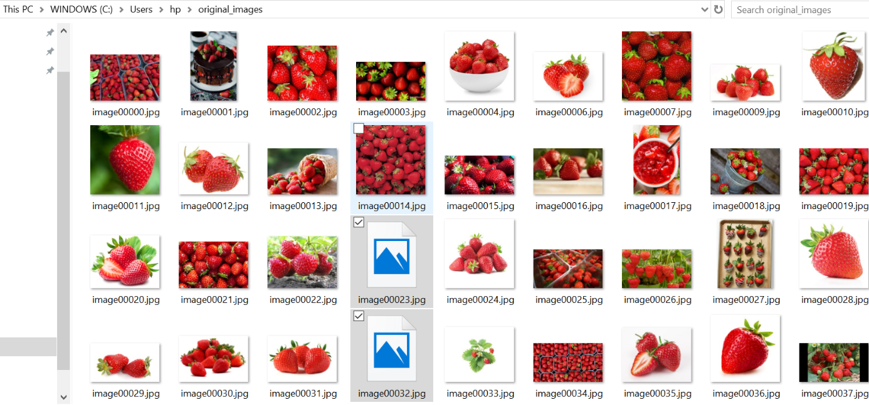

As seen above there were few pictures which were corrupt so they have been deleted in order to run the next code smooth.

The above code shows the pictures have been successfully downloaded in the folder.

**Step 2**

The next step is to use the augumentor to create 10 images with effects such as rotation, flip, colour and skew. The pictures have been successfully uploaded in the “**augumeneted_images/output**“ folder though the code dealt with few errors during running. Below is snapshot of the steps used to get augumented images.

After running the above code, the pictures have been successfully augumented with effects as shown in the below folder. In order to create pictures with successful copies of each pictures, it produced more than the expected picutures which sums up to 2768. Below is a screeshot of the augumented folder:

**Step 3**

In step 3, cropping tool has been used and it cropped images which are stored in “**augumented_images**“ which are shown in the following screenshot:

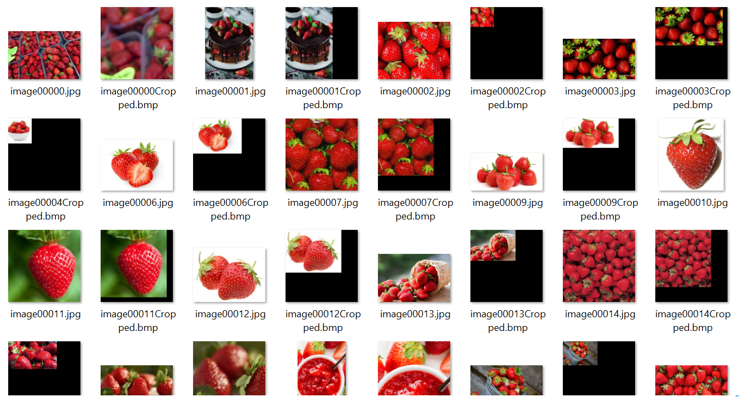

The bounded box used for mouse clicks has been created using the below code:

To create the bounded box for using the mouse clicks, it has been made through the below code though unfortunately it dealt with “system exit 2“ error and to write the file in as xls also dealt with one error which are unfortunately not fixed so it couldn’t be able to run. Below are screenshots of the same:

**Lessons Learned:**

There has been a lot of learning overall. The introduction to new tools such as augumentor and step building for downloading google images automatically and maniputation of images has been a great learning throughout.

**Challenges Faced:**

1. The augumentor part produced multiple copies of each image and still showing an error and it produced more then expected that still needs to be fixed.
2. Enough time has been spent on Step 3 but failed slightly to deal with the issue it raised for argparse error i.e. System 2 error and creating xls file which is still to be learned in future.